Pupil premium strategy statement - Tattenhall Park Primary School
Year 3 of Year 3 Plan- This statement details our school’s use of pupil premium (and recovery premium) funding to help improve the attainment of our disadvantaged pupils. It outlines our pupil premium strategy, how we intend to spend the funding in this academic year and the outcomes for disadvantaged pupils last academic year.

School overview
Detail | Data
Number of pupils in school | 212
Proportion (%) of pupil premium eligible pupils | 20 pupils (8.9%)
Academic year/years that our current pupil premium strategy plan covers (3 year plans are recommended) | 2022/2023, 2023/24 and 2024/25
Date this statement was published | 10.12.24
Date on which it will be reviewed | 10.07.25
Statement authorised by | Nicola Bolton
Pupil premium lead | Michelle Mason
Governor / Trustee lead | Peter Brown

Funding overview
Detail | Amount
Pupil premium funding allocation this academic year | £32,560
Recovery premium funding allocation this academic year | £0
Pupil premium (and recovery premium*) funding carried forward from previous years (enter £0 if not applicable)  *Recovery premium received in academic year 2021 to 2022 can be carried forward to academic year 2022 to 2023. Recovery premium received in academic year 2022 to 2023 cannot be carried forward to 2023 to 2024. | £0
Catch-up tutoring funding | £0
Total budget for this academic year  If your school is an academy in a trust that pools this funding, state the amount available to your school this academic year | £32,560

Part A: Pupil premium strategy plan

Statement of intent
- At Tattenhall Park Primary, we have high aspirations and ambitions for our children and we believe that all learners should be able to reach their full potential.
- We strongly believe that reaching your potential is not about where you come from, but instead, about developing the necessary skills and values required to succeed.
- Our pupils in receipt of the Pupil Premium Funding may face specific barriers to reaching their full potential, and, at Tattenhall Park, we are determined to provide the support and guidance they need to help them overcome these barriers.
- In addition to this, we aim to provide them with access to a variety of exciting opportunities and a rich and varied curriculum.

Challenges
This details the key challenges to achievement that we have identified among our disadvantaged pupils.
Challenge number | Detail of challenge
1 | Increasing attainment gap across Reading, Writing and Maths while ensuring that the broad curriculum is also fully inclusive for all children.
2 | Impact of school closure due to Covid-19 on pupil wellbeing and emotional support for all pupils, including those eligible for PP.
3 | Recovery of Reading for Pupil premium children (after COVID). This includes speech and language difficulties and a lack of exposure to a wide range of vocabulary.
4 | Pupils and their families have social & emotional difficulties, including medical and mental health issues.
5 | A significant proportion of persistent absentees are disadvantaged (19% 24/25)
6 | Many of our PP children do not possess the phonological knowledge and understanding in line with their peers nationally and in school (particularly year 6- 24/25)

Intended outcomes
This explains the outcomes we are aiming for by the end of our current strategy plan, and how we will measure whether they have been achieved.
Intended outcome | Success criteria
Increase of KS1 and 2 attainments in reading, writing and maths– including catch-up provision. Closing gaps agenda for PP pupils. | Support groups planned, resourced and evaluated effectively to ensure that they have the maximum possible impact. Achieve national average progress scores in KS1 and KS2
Increased well-being and emotional support for all pupils, including those eligible for PP | Support groups continued for PP children with trained TAs when required. Focus on mindfulness across school and raised awareness of everyone’s mental health
Disadvantaged pupils maintain at least the standard of attainment they achieved at the end of the previous year (Reading, Writing and Maths) and previous key stage; those who have ‘fallen behind’ make accelerated progress and ‘catch up’ or exceed prior attainment standards.  To ensure fallen behind children receive targeted high-quality intervention monitored by intervention leader. | End of summer 2022, 2023, 2024, 2025 data will show that 95 – 100% of disadvantaged children have made expected progress from the previous summer.  End of summer data will also show that 10 – 20% of disadvantaged children will have made accelerated progress.  Analysis of interventions will show that interventions have had a positive impact on the disadvantaged children’s learning and has helped in accelerating their progress.

Activity in this academic year
This details how we intend to spend our pupil premium (and recovery premium) funding this academic year to address the challenges listed above.
Total Budgeted cost: £32,560

Teaching (for example, CPD, recruitment and retention)
Teaching Budgeted cost: £32,094
Activity | Evidence that supports this approach | Challenge number(s) addressed
Teaching Assistants to deliver interventions, nurture and work with pupil premium children across the school.  £7483  + £2,496  KS2 Phonics, Toe By Toe and Maths (NumberStacks)  £4680 | EEF  “As the size of a class or teaching group gets smaller it is suggested that the range of approaches a teacher can employ and the amount of attention each student will receive will increase, improving outcomes for pupils.”  We have analysed the needs of our PP cohort and have identified a number of children who would benefit from smaller group teaching and interventions this will allow us to increase the amount of attention each child will receive. Allocations of TAs to ensure that each class has at least morning support in maths and English for lower attainment children in KS2. Extra TA support with KS2 children in phonics has been facilitated. Smaller working groups working on sounds more accurately with those children. | 1, 3, 6
ELSA  £624 | A number of our disadvantaged children need support with emotional needs and behaviours, with this being the biggest barrier to them accessing to and progression within their learning. By training our learning support mentor in ELSA, we will be meeting such needs on an individual basis and being able to target other resources for where they are most needed. In addition to this, the ELSA trained staff can deliver this to other staff in school to build self-improvement within this area in our staff. See rationale for this approach above. | 2, 4
NELI  £1560 | EEF  The Nuffield Early Language Intervention (NELI) programme is designed to improve the language skills of reception pupils (aged 4 – 5) and involves scripted individual and small-group language teaching sessions delivered by trained teaching assistants (TAs).  NELI is published by Oxford University Press and was delivered in this trial by the University of Oxford in partnership with Elklan. The 20-week intervention consists of two 15-minute individual sessions and three 30-minute small group sessions each week, which focus on developing children’s narrative, vocabulary and listening skills, in addition to their phonological awareness and letter sound knowledge.  The children selected to participate in this were the six children in the classroom who obtained the lowest scores on a school-administered app-based assessment of oral language skills (LanguageScreen).  TAs have received two days of initial training, followed by ongoing support, while teachers also attend an initial half-day of training so that they can understand the programme and support TAs. | 3, 6
WELLCOMM  £1560 | WELLCOMM  According to the latest data released by the DfE (24 June 2021), speech, language and communication needs (SLCN) are the most common type of primary special educational need (SEN) in state schools. Almost 295,000 children were listed as having SLCN as a primary SEN in early 2021. Our service works closely with our partners in NHS Speech and Language Therapy Services, and we know that they are inundated with referrals for assessment and advice.  EEF  Early Years Toolbox Report | 3, 6
SALT  £780 | A number of our younger disadvantaged pupils will benefit from additional oral language development as highlighted in their initial Wellcom speech and language toolkit (see above). This work is delivered by class staff wherever possible but guided and supported by our specialist SALT TA (trained for school level advice by local SALT team). | 1, 3, 6
Improvement of Phonics and Reading Comprehension Strategies across EYFS/KS1 and to provide intervention in KS2. Additional staff trained to ensure improved outcomes for disadvantaged children.  £1410 (Training)  £1560 (Delivery) | Reading and comprehension are the fundamentals of learning and understanding so an increase in targeted support within these areas serves to aid disadvantaged pupils improve further, across the curriculum whilst also developing self-confidence, resilience and engagement. Research shows an average of 5 months’ additional progress can be achieved, along with developments in independent and collaborative learning strategies. | 3, 4, 5
Ensure disadvantaged children are challenged appropriately through curriculum and receive high quality teaching and learning through the roll out and resourcing of mastery programmes. Main school budget to cover costs  £0 | EEF research shows that a mastery learning approach has a +5 rating in effectiveness. It is also particularly useful for narrowing any attainment gap for all learners of all abilities. A high expectation of work from disadvantaged learners (a recommendation from the EEF), is consistently expected by all teachers and support staff; along with the use of effective teaching schemes and resources, such as WhiteRose units, Pathways to Write, Steps to Read and Read, Write, inc Phonics. This will ensure all disadvantaged children have access to and are challenged appropriately. Money to be spent on resources, training for staff in the programmes listed about and individual resources as required by specific learners as identified by staff who work with them. | 3, 4, 5

Targeted academic support (for example, tutoring, one-to-one support, structured interventions)
Budgeted cost: £1560
Activity | Evidence that supports this approach | Challenge number(s) addressed
Further Develop IDL programme  (TA Support)  £1560 | https://www.idlsgroup.com/case-studies/accelerating-literacy  IDL Literacy effectively improves reading and spelling amongst pupils with various literacy problems, removes visual stress by the use of colour, and is very effective overall – particularly with those who have poor phonological skills. The effectiveness is due to the integration of reading and writing, the integration of visual and auditory cues to teach letter/sound and blend/sound correspondence, a continuum of exercises that start with recognising the alphabet, and the requirement to re-read typed sentences. | 1, 3, 6

Wider strategies (for example, related to attendance, behaviour, wellbeing)
Budgeted cost: £8,381
Activity | Evidence that supports this approach | Challenge number(s) addressed
Extended opportunities to attend after school clubs and activities for children eligible for FSM including Athletics, Gardening, Science Club, Forest School.  £900 (Gardening Club, Science and Forest School materials) | Evidence indicates that, on average, pupils make two additional months' progress per year from extended school time by the targeted use of before and after school programmes. There is some evidence that disadvantaged pupils benefit disproportionately, making approximately three months’ additional progress. After school programmes that support and encourage children academically while providing stimulating environments and activities are more likely to have an impact on attainment. Clubs including sporting and non-academic clubs are also shown to be beneficial and help to increase engagement in school life. Many of these opportunities are provided by staff at no additional cost to the budget. Most opportunities have either an Arts or Physical aspect to them, both of which are evidenced to impact positively. Some outside providers offer free places for children in receipt of FSM. This has negated the cost of providing for this area of our provision c. | 1,4.5
Development of the ‘Wildery’ as part of Forest School to develop activities for PP children.  £2400  + £500 (Materials) | Outdoor learning can increase Pupil Progress by an average of 9 months- DfES 2006 Learning Outside the Classroom Manifesto. | 1,4,5
Trips and visits – organise trips linked to curriculum & support financially if necessary  Residentials- £1391  Trips- £550  Swimming- £466 | Residential trips are proven to support growth mind sets, increase confidence and teach team building skills. Children learn vital life skills of perseverance and resilience and this in turn impacts on their academic progress within lessons as they are able to apply these skills when back in the school environment. | 1,4,5
Head teacher to ensure that parents are made aware of expected attendance levels when they fall below 90%.  £2,040 | EEF – Attendance intervention  Report on Rapid Attendance intervention  Poor school attendance is a significant problem in the UK and many other countries across the world. In 2019/20, it was reported as 4.9% overall, with special schools showing a higher rate equal to 10.5% and persistent absence at 13.1% in England (gov.uk 2020). Research has found that poor attendance at school is linked to poor academic attainment across all stages (Balfanz & Byrnes, 2012; London et al., 2016) as well as anti-social characteristics, delinquent activity and negative behavioural outcomes (Gottfried, 2014; Baker, Sigmon, & Nugent, 2001). However, evidence suggests that small improvements in attendance can lead to meaningful impacts for these outcomes. | 1,4,5
Support for Transitions for Nursery Pupils going into Reception, Year 6 pupils going into Year 7- cover  £600 | EEF- Transition support  Report on supporting pupils through transitions.  ‘We know that transitions between classes, year groups and settings will be of significant importance in the lead up to the new academic year. It is challenging to get school transitions right for all pupils, whether they are moving to the classroom next door or to an entirely new setting. A high-achieving learner can struggle if curriculum expectations at their new setting are low. A pupil with SEND can thrive due to a highly bespoke transition with additional visits and scaffolds for new routines. There are differential experiences, and we cannot make sweeping statements about particular groups, as some pupils may struggle with new classroom routines but not friendship networks and vice versa.’ | 4,5

Total spent:

Part B: Review of the Year 2 academic year
Year 2 Review (2023-24) |  | Amendments for next year
Impact | Issues
Whole school Below EXP Progress TOT 202 Whole school EXP progress TOT 202 Whole school Above EXP Progress TOT 202 Whole school PP Below EXP Progress TOT 26 Whole school PP EXP progress TOT 26 Whole school PP Above EXP Progress TOT 26  READING 5 (4%) 85(71%) 29(24%) 0 (0%) 21 (72%) 9 (28%)  WRITING 2 (1%) 96 (81%) 21 (18%) 0 (0%) 22 (75%) 8 (25%)  MATHS 10 (8%) 88 (74%) 21 (18%) 2 (6%) 24 (81%) 4 (13%)  Data shows that accelerated progress was made by 9 children (28%) in Reading, 8 (25% in writing) and 4 (13%) in Maths. Contextually there is very little reading being done at home with the disadvantaged children due to barriers to learning within households. Children do access 1:1 daily reading in school and staff will be encouraged to ensure this is maintained in 24/25.  Interventions were carried out to impact teaching and learning to the cost of £23,587. Children accessed reading interventions and this ensured a small amount of children made accelerated progress. The children also accessed Maths interventions, where again a small number of children made accelerated progress. | In Maths, 6% of children made below expected progress. Maths interventions are crucial to ensure that gaps are closed.  Across all 3 areas, high priority remains to resourcing high quality teaching and learning from teachers and teaching assistants across school. Quality first teaching/mastery approach is crucial which is in line with EEF guidance (linked to strong research findings that this has the most significant impact on accelerating progress). Much of this is a key part of our strategic thinking for disadvantaged learners but does not have an additional cost now that it has reached the embedding point.  Mental Health and Emotional Wellbeing Mental Health and Emotional Wellbeing concerns continue to be an issue for a number of our children. It is important that this continues to be a focus. | Having reviewed the impact of the plan for the year 2023-24, the Pupil Premium Lead and the Senior Leadership Team considers the priorities previously set to be still appropriate and relevant to giving our Pupil Premium pupils the best chance to achieve accelerated progress. Targets for 2023/24;  - Disadvantaged pupils maintain at least the standard of attainment they achieved at the end of the previous year (Reading, Writing and Maths) and previous key stage; those who have ‘fallen behind’ make accelerated progress and ‘catch up’ or exceed prior attainment standards.  - To ensure fallen behind children receive targeted high-quality intervention monitored by intervention leader.  - End of summer 23/24 data will continue to show that 95 – 100% of disadvantaged children have made expected progress from the previous summer.  - End of summer data will also show that 10 – 20% of disadvantaged children will have made accelerated progress.  - Analysis of interventions will show that interventions have had a positive impact on the disadvantaged children’s learning and has helped in accelerating their progress.
Outcomes for disadvantaged pupils
2023/24 – Disadvantaged attendance = 92.1% (non-disadvantaged = 95.3%) NAT AVG 91.8%
2023/24 Persistent Absentee Percentage – Whole School = 13.9% NAT AVG 16.8%
2023/24 Percentage of Persistent Absentees who are disadvantaged = 26.9% NAT AVG 27.6%

Part B: Review of the Year 1 academic year
Year 1 Review (2022-23) |  | Amendments for next year
Impact | Issues
PP Breakdown - EXP or above progress  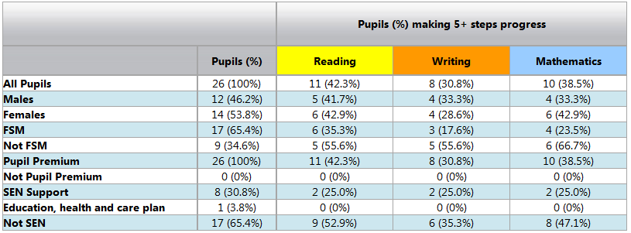  Whole School Breakdown - EXP or above progress  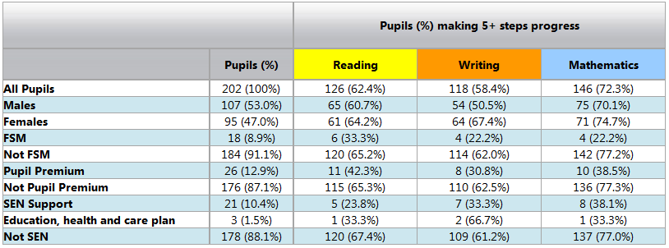  Data shows that accelerated progress was made by 3 (11%) in reading, 2 (8% in writing) and 5 (20%) in maths. Contextually there is very little reading being done at home with the disadvantaged children due to barriers to learning within households. Children do access 1:1 daily reading in school and staff will be encouraged to ensure this is maintained in 23/24).  Only 30% of disadvantaged children making expected progress from previous Summer scores (this will be relayed to staff as a focus).  Interventions were carried out by class teachers to the time cost of £19,000. Children accessed reading interventions and this ensured a small amount of children made accelerated progress. Contextually there is very little reading being done at home with the disadvantaged children due to barriers to learning within households, this has a negative impact on the intentions of the interventions. | Whilst the attainment gap between disadvantaged and non-disadvantaged children in Reading, Writing and Maths remains a high priority for all cohorts, closing the significant gap evident in Writing remains our main priority for 2023-24. This will remain the key focus of this 3 year plan. Only 30% of disadvantaged children made expected progress from previous Summer scores.  Across all 3 areas, more high priority remains to resourcing high quality teaching and learning from teachers across school as opposed to focusing on intervention staff with a view to taking a quality first teaching/mastery approach in line with EEF guidance linked to strong research findings that this has the most significant impact on accelerating progress. Much of this is a key part of our strategic thinking for disadvantaged learners but does not have an additional cost now that it has reached the embedding point.  Covid Impact- Many of our disadvantaged children attended school at least part time during lockdowns, and all were offered a place however some parents declined this offer. This has meant a wider gap to close for some. During the lockdowns, SLT ensured all children were able to access remote lessons with hardware loans and support for those who couldn’t, however a higher number of disadvantaged children not attending school did not engage at all or as fully compared to non-disadvantaged peers. This had a cumulative impact on the attainment of a significant number of disadvantaged pupils. For those who were at home, our learning support mentor held regular check ins with children and there were daily live lessons and a range of learning activities offered online and through resource packs. A small number of children did not receive in person peer interaction and in person teaching during this time due to parental choice. For some this has heightened emotional and behavioural traits.  Mental Health and Emotional Wellbeing Mental Health and Emotional Wellbeing concerns continue to be an issue for a number of our children. | Having reviewed the impact of the plan for the year 2022-23, the Pupil Premium Lead and the Senior Leadership Team considers the priorities previously set to be still appropriate and relevant to giving our Pupil Premium pupils the best chance to achieve accelerated progress. Targets for 2023/24;  Disadvantaged pupils maintain at least the standard of attainment they achieved at the end of the previous year (Reading, Writing and Maths) and previous key stage; those who have ‘fallen behind’ make accelerated progress and ‘catch up’ or exceed prior attainment standards.  To ensure fallen behind children receive targeted high-quality intervention monitored by intervention leader.  End of summer 23/24 data will show that 95 – 100% of disadvantaged children have made expected progress from the previous summer.  End of summer data will also show that 10 – 20% of disadvantaged children will have made accelerated progress.  Analysis of interventions will show that interventions have had a positive impact on the disadvantaged children’s learning and has helped in accelerating their progress.
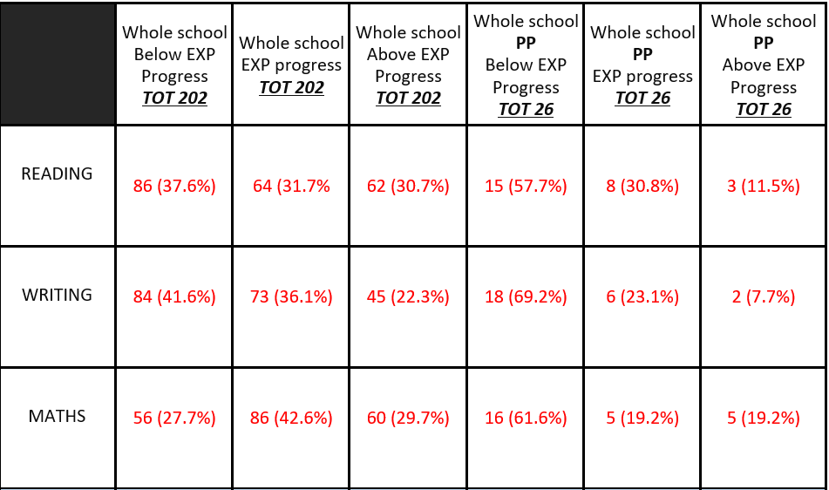 | Outcomes for disadvantaged pupils  2022/23 – Disadvantaged attendance = 92.3% (non-disadvantaged = 94%) NAT AVG 93.7%  2022/23 Persistent Absentee Percentage – Whole School = 15.6% NAT AVG 19.4%  2022/23 Percentage of Persistent Absentees who are disadvantaged = 32.3% NAT AVG 19.4%

Glossary
PPG – Pupil Premium Grant
FSM – Free School Meals
PLAC – Previously Looked After Children
ARE – Age related expectations

