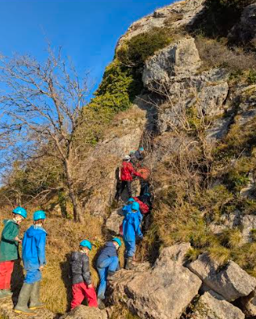**Dear Tattenhall Park families, Friday 16th January, 2025**

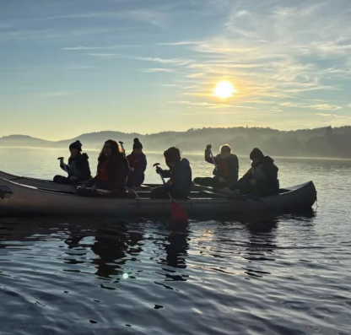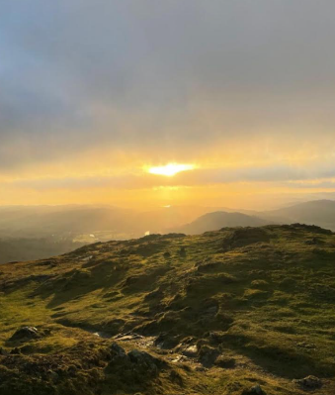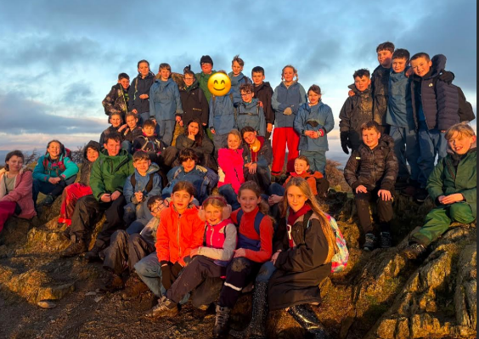Year 6 have just returned from three days of gorgeous winter weather and wonderful adventures at Ghyll Head . The photographs they have shared on Instagram have been absolutely spectacular. A huge thank you to all the staff who have supported the children; Miss Comish, Mrs Mason, Mrs Barton, Mr Cragg, Mrs Gibson, Mrs Tomlinson and Mrs Roberts, they will be having a very well deserved rest tonight!

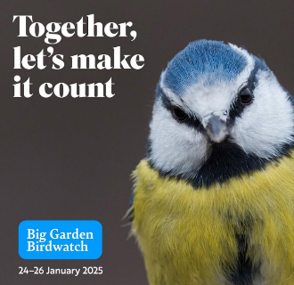

**Big Garden Birdwatch**

In assembly this week we talked about the founder of the RPSB Emily Williamson and learnt some of the bird calls we could hear in our gardens to prepare for the Big Garden Birdwatch . It would be lovely if lots of the children take part in the

Big Garden Birdwatch next weekend. Next week, the children will bring home bags of seed and a leaflet, which explains how they can take part.

[www.rspb.org.uk/whats-happening/big-garden-birdwatch](http://www.rspb.org.uk/whats-happening/big-garden-birdwatch)



**Whole school homework: History Detectives: Our Village, Our Future**

This week, all the children in Acorns and Years 1, 2, 3, 4, 5 and 6 have been given a history task for homework. This is part of our film preparations for ‘Our Village, Our Future’. Each year group has been given a different period of history to explore Tattenhall through the ages. We will be collating all this information into a film script over the next few weeks.

Don’t forget, if you have any local knowledge you would like to share, or know a member of your family who does, we will be holding a coffee and cake history sharing session will be **Monday 20th January at 9am in TASC**.



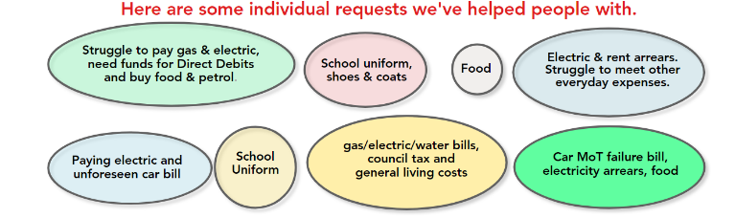**Tattenhall Cares** have reached out to us to ask us to remind you that they have a fund available to anyone living within the Parish Council boundary in need of temporary help to alleviate immediate hardship. If you are under any kind of financial pressure they would love you to get in touch by emailing: [**tattenhall.cares@gmail.com**](mailto:tattenhall.cares@gmail.com)

All applications are strictly confidential.

Have a wonderful weekend, Nicky Bolton, Headteacher